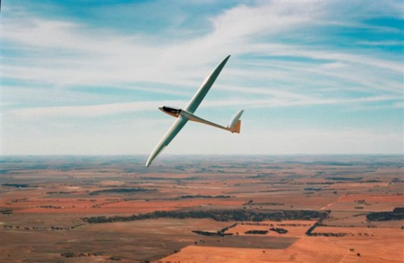**Thermal Centring**

**Part 1 Maintaining position.**

I heard of a conversation many years ago where it was being discussed, in what direction should a novice pilot fly on the first leg of their first flight. Up wind, down wind or cross wind? Brian Spreckley’s comment, who at the time was the British Gliding Association coach and later word 15m champion.  
“It does not matter which way they fly if they cannot thermal properly.”

So I will try in this article to give the basics on how to thermal properly. I will not go into thermal sources or the subtleties of different thermals, other than to say that when flying cross country. From the moment you take off from the ground your job is to continually look for the best part of a thermal and where the next thermals on track will be.

Let us first be aware that the glider is flying in an envelope of air that is going up, a thermal, that is surrounded by air that is not. Our job is to stay in that envelope of air and climb with it. Now to stay on the ground in one spot is easy, just don’t move, as you do in an elevator. Get in the elevator and press the button and up we go. The problem is in an aircraft we have to keep moving. If we were in a car park in a car and wanted to keep driving around a witch’s hat we would put on a given amount of lock on the steering wheel and provided we maintain that exact lock we will go round and round the same track with the witch’s hat in the centre of the circle. All very easy. But now consider being in a glider. We can put on an angle of bank and fly at a constant speed and we will fly around the same spot in the envelope of air that we are rising in. Simple.

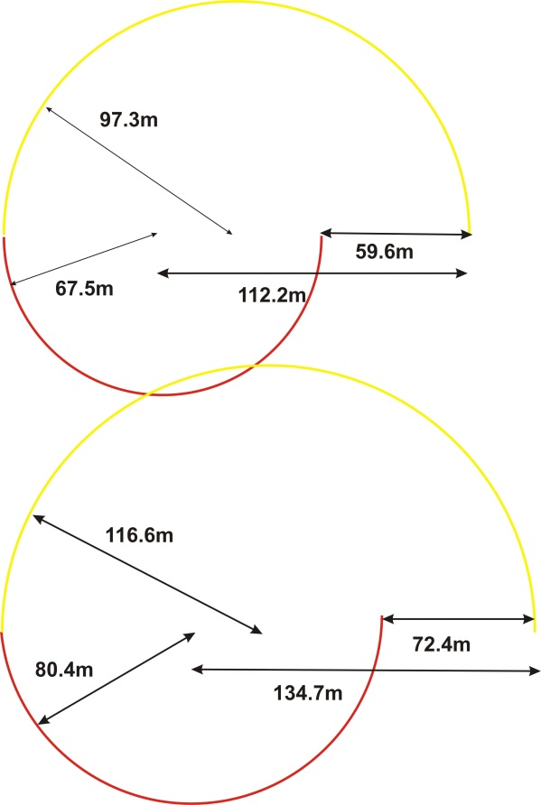Well not so simple. Firstly we do not have a witches hat as a visual reference and many people fail to maintain a constant speed and bank angle. I first need to point out that most modern gliders are designed to be able to fly in a thermal by maintaining an angle of bank of 45° with a speed a few knots above stall speed, and thus be able to fly in the strongest part of the thermal that is going up. Any higher speed or lower angle of bank will make the glider fly away from the strongest part of the thermal and possibly in sinking air. If the glider did not perform to these requirements it would not thermal efficiently. So provided we fly an accurate circle we will usually stay in the thermal. As in an article by Greg Beecroft that I read many years ago stated. The question I asked myself was.  
“How accurately?”

I drew up a chart with the diameter of a turn at different speeds and angles of bank and considered a glider flying half a turn at 45° degrees at a speed of 50 knots, the radius would be 67.5m. Now if the pilot, due to their low skills reduced the angle of bank by only 5° and increased their speed by only 5 knots the radius would become 97.3m. So with half the turn at 67.5m and the second half of the turn being 97.3m the circle will have shifted 56.9m.

So going back to our first two scenarios of being in a lift or in a car where we can maintain our position, we can see in a glider that with inaccurate flying we can wander around the sky oblivious as to our location relative to the centre of the thermal. So in addition to Greg’s comment, fly accurately the answer is.  
“Fly VERY ACCURATELEY.”  
For a pilot who cannot bank in the first place at 45° but flies at 40° and 50kts (80.4m radius) and changes to 35° and 55kts (116m radius) their circle will shift 72 meters!

So how do we learn to fly Very Accurately? Firstly by practice and not being satisfied with anything better than a 45° angle of bank plus or minus nothing! And a speed that we can maintain plus or minus nothing.  
This is all very good in theory so let’s look at the two variables.

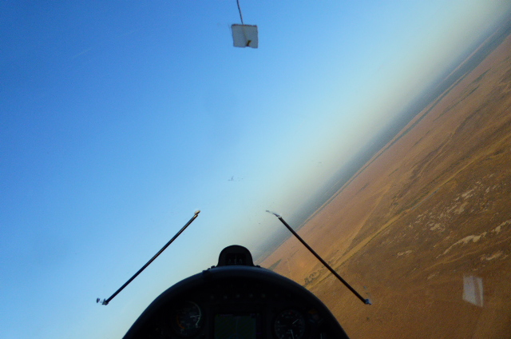  
**Angle of bank.** During a coaching week run by John Buchanan we were drilled into flying accurately. To help us maintain our angle of bank we would put two straws on the inside of the canopy, attached by a little bit of blue tack. These were positioned at 45° and well up the front of the canopy, in our relative long distance focus. When we rolled into a turn the straws would sit parallel to the horizon and measure our bank, spot on. After over 3000 hours of flying I still use these straws to monitor my exact flying. I am continually told by pilots other easier ways, little rabbits ears, screws on the compass, but these do not shout at me, and the pilots who have the other ideas generally don’t fly faster than me.

**Speed.** My comment about maintaining speed needs clarification. When flying in a thermal we are being buffeted by horizontal wind gusts that will vary the speed being shown on the ASI. What we need to do is fly very accurate speed based on our angle of attack, thus we need to position the nose of the glider accurately relative to the horizon. So whilst looking ahead we can not only see our straws sitting on the horizon, we can also monitor and maintain our angle of attack, Accurately, Very Accurately.

**What Speed?** Many students are still instructed to fly as near to stall speed as possible when thermalling, to reduce their sink rate. In addition it is drummed into them that the yaw string should sit down the centre line of the glider. Unfortunately both these ideas are wrong. Most gliders minimum sink rate is not just above stall speed but perhaps 10 knots faster. Although this is worth noting it is far less relevant than the ability to feel and control the glider. At very slow speeds the glider feels mushy, and does not respond to control inputs. Adding a little extra speed allows the pilot to enter corrections inputs and the glider responds, whilst not battling the gusts that the glider is subject to.

**Yaw StringYaw String.** As stated a little earlier we have it drummed into us to have the yaw string down the middle of the aircraft. Let me first say that when flying straight and level this is the case, but as soon as we go into a turn the yaw string starts telling us all sorts of lies. The diagram indicates that when turning in a circle, if flown accurately, the yaw string will hang out to the outside of the circle, and whereas in the diagram that is not to scale it shows the yaw string about 5 – 10° out of centre. In reality the wind over the canopy exaggerates this angle, thus making the diagram relatively true. The problem is that if you fly the glider with the yaw string down the middle when thermalling, in reality the nose is pointing to the ground more than you think and you will have a battle maintaining bank and speed. So next time you are battling with the glider in a thermal put in a bit of top rudder and Bingo! You will find life so much easier.

So now after much discussion I hope that you know how to fly a glider in one spot in the air and not wander around the sky like a drunken sailor. Now we have to find the centre of the thermal and core it. But without being able to go back to a constant turn we are wasting our time.

Practice these skills and don’t be satisfied with anything better than 45° at about 10knots above stall.  
**Accurately, Very Accurately.**

**Part 2 Finding the core.**

Before I start I need to state that the techniques assume that a glider can go from straight and level to 45° instantly. This is, as we all know not to be correct. However the principles of the diagram hold good for the basics. To compensate for the rate of roll of the glider we need to pre-empt what is going to happen to the air in front, and start the control inputs earlier than my explanations. This skill comes with experience.

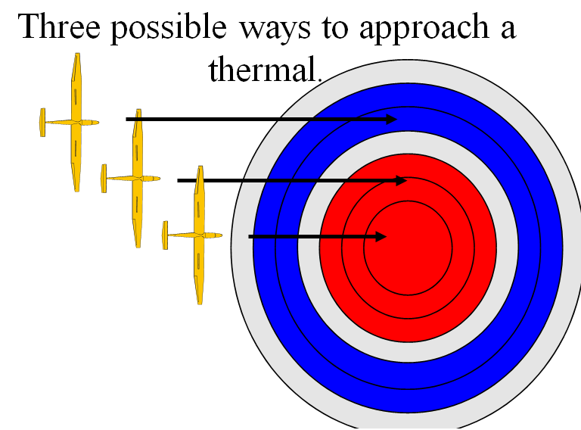John Williamson, I think the first BGA coach, who visited GCV for some years as resident instructor and the initiator of Lead and Follow coaching would describe approaching a thermal with the use of a witch’s cone where the peak of the cone indicated the strongest part of the thermal.

The following Diagrams indicate the cross section of a thermal, the Red being the rising air, the Blue being the sinking air around the outside of the thermal and the grey being the turbulent air, between the rising and sinking air.

I will now suggest the way to core the thermal on the first turn, depending upon where you approach the thermal. On the edge, in the middle or Goldilocks Just right.

In all cases it is important to be aware that the higher the speed you approach the thermal the more likely you are to miss it. We all have a reaction time. In athletics if an athlete starts sooner than 0.1 of a second after the gun, they are considered to have jump started as the brain cannot react that fast. As glider pilots we have to react to a considerable number of inputs to decide when to turn and how much. So to give us time to make the decision as we approach the thermal and we feel the pre thermal buffet, Slow Down. You are better to spend a bit more time in the sink and get the core right, rather than blast through and miss the thermal completely.   
With a thermal diameter of 150m it will take a glider travelling at 120 kts 2.5 seconds to pass through the thermal  
85 kts 3.5 seconds  
60 kts 5 seconds

In addition when you slow down start to get your mind in sync with the gliders feel that it is telling you about the thermal. You will also be able to feel the thermal better when you are flying slower. At high speeds you will feel virtually nothing.

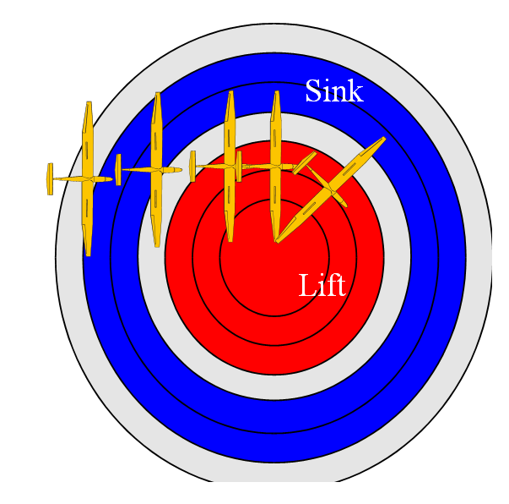Let’s start with the Goldilocks approach. By chance we get things “Just right”   
1)As we approach the thermal we begin to feel the pre thermal turbulence with a little buffeting, (the first grey ring,)   
2) We switch on our brain to monitor what the thermal is telling us.  
3) As we hit the sink slow down a bit.  
4) As you hit the stronger turbulence you should be getting the speed back to 60 – 70 kts so you have the reaction time.  
5) You will notice that the right wing in our case is lifting. Keep flying straight, but be ready to turn.  
6) As you fly into the rising air you will feel it accelerate the glider upwards. Monitor this vertical acceleration and at the point that the vertical acceleration drops off feed in Maximum rudder and balance the turn with the ailerons into your Standard Thermalling Turn 45° bank and about 10kts above stall.  
7) Bingo you are in the core of the thermal.

Before we look at the other means of approaching the thermal let’s consider the vertical accelerations that we feel and understand what they are telling us.

If we go into an elevator, and the doors have shut. If someone presses the button we know immediately if we are going up or down by the push on our legs. What is vital to understand that the vertical push will continue until we reach maximum vertical speed, at which point there is no vertical push other than the 1 G load we are subject to when standing on our Earth. So get this concept solidly in your mind.

The thermal push means that you are approaching the core, you are not there yet. It is not time to turn.

When the vertical acceleration has stopped you are going up at maximum speed. No time to wait give full controls and get the glider into thermalling mode.

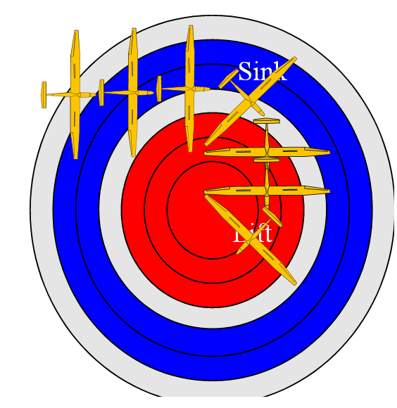Approach option two. We approach the thermal along one edge.

1) As we approach the thermal we begin to feel the pre thermal turbulence with a little buffeting, (the first grey ring,)   
2) We switch on our brain to monitor what the thermal is telling us.  
3) As we hit the sink slow down a bit.  
4) As you hit the stronger turbulence you should be getting the speed back to 60 – 70 kts so you have the reaction time.  
5) You will notice that the right wing, in our case is lifting. BUT you are not feeling any vertical acceleration.  
6) Make a distinct turn towards the lifting wing, then fly straight.  
7) As you fly into the rising air you will feel it accelerate the glider upwards. Monitor this vertical acceleration and at the point that the vertical acceleration drops off feed in Maximum rudder and balance the turn with the ailerons into your Standard Thermalling Turn 45° bank and about 10kts above stall.  
7) Bingo you are in the core of the thermal.

Finally we will look at hitting the thermal straight up the middle.

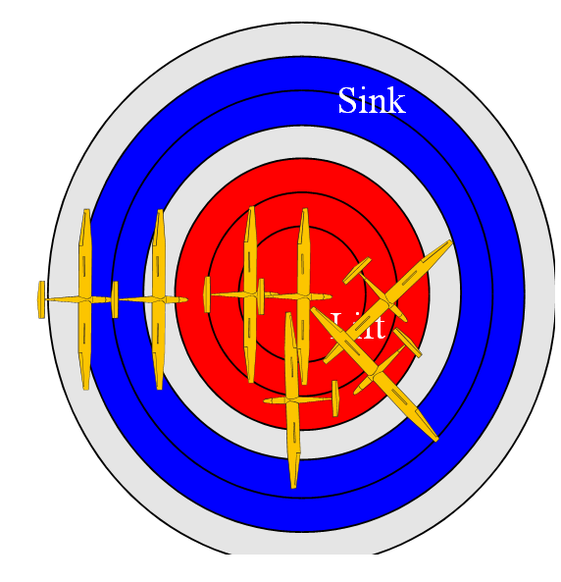1) As we approach the thermal we begin to feel the pre thermal turbulence with a little buffeting, (the first grey ring,)   
2) We switch on our brain to monitor what the thermal is telling us.  
3) As we hit the sink slow down a bit.  
4) As you hit the stronger turbulence you should be getting the speed back to 60 – 70 kts so you have the reaction time.  
5) You will not notice either of the wings lifting. Keep flying straight, but be ready to turn.  
6) As you fly into the rising air you will feel it accelerate the glider upwards. Monitor this vertical acceleration and at the point that the vertical acceleration drops off make a decision to turn one way, feed in Maximum rudder and balance the turn with the ailerons. Be prepared for 180° of the turn to have a little more than 45° of bank.  
7) Once you have completed the half steep turn open out your turn to Standard Thermalling Turn 45° bank and about 10kts above stall.  
6) Bingo you are in the core of the thermal.

**Getting the Thermal Entry Turn Wrong.**

So we are not always perfect when finding a thermal what happens if we turn the wrong way, or even turn in a thermal that proves to be unsatisfactory. The idea of slowing down and sampling the thermal is that it allows you to make a decision to take the thermal or leave it, so if it is not satisfactory move on. Don’t hang about in something that is not going to make you climb at an acceptable rate. Know your acceptable rate and stick to it.

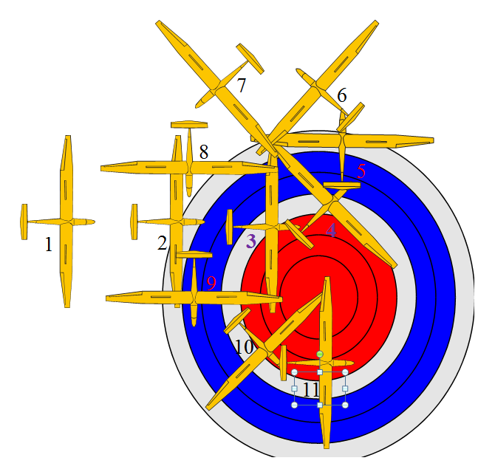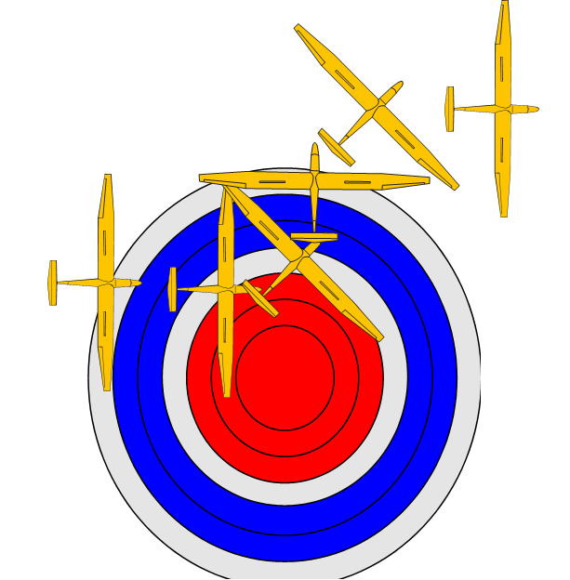Alternatively you may have got all the inputs and made a turn say to the left, and then run into sink half way through the turn.   
The first option is to roll back out of the turn and head on track, and find another thermal.

The second option it to find the thermal’s core that you missed. I have heard of other techniques to what I suggest, but I believe the technique I will explain takes into account the gliders existing bank, and requires minimal changes in direction, that will lead you to the core quicker and more accurately. Also more predictably if flying with other gliders.

The probability is that you turned the wrong way, let’s say left rather than to the right, ( 1 to 5 in the diagram. )..  
Once you have turned 90° and you start to run into sink it is quite clear you have gone the wrong way. You are already flying at 45° to the left, expecting it is the core you are in, but very quickly you know you are wrong. Tighten up the turn a bit more, to get out of the sink as soon as possible and continue doing so until you have completed a 270° degree turn (6 – 8 in the diagram). Then straighten out with full control movements of the rudder and balancing the turn with the aileron.   
Now fly straight feeling the air as in the previous diagrams. Generally you will be entering the thermal in the Goldilocks position, so.  
1) You will notice that the left wing in our case is lifting. (8 -9 in the diagram) Keep flying straight, but be ready to turn.  
2) As you fly into the rising air you will feel it accelerate the glider upwards. Monitor this vertical acceleration and at the point that the vertical acceleration drops off feed in Maximum rudder and balance the turn with the ailerons into your Standard Thermalling Turn 45° about 10kts above stall. (9 – 10 in the diagram).  
7) Bingo you are in the core of the thermal. (11).

**Re-centring your turn.**

I think that we all know that once we have found the core of the thermal we need to keep making inputs into our turn to correct it. I will assume that we are flying by ourselves rather than with another glider, that I will come to later.

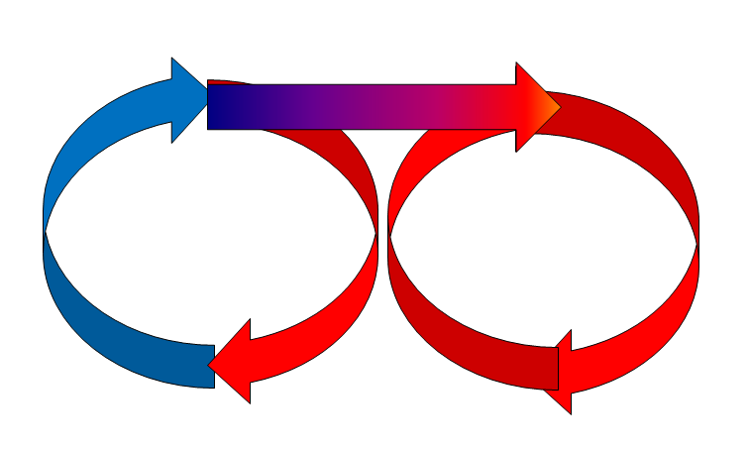As we turn in the thermal. At our standard 45° bank and about 10kts faster than stall, we will start to notice that part of the turn is going up stronger than the other half. We will need to shift the turn towards the better part of the thermal. In the diagram we are in the left circle and need to move to the one on the right. As you start to exit the area of sink and begin to feel the surge of the core. Give full control inputs and move towards the lift. Keep flying straight until you feel that you are at maximum rate of climb. Monitor this vertical acceleration and at the point that the vertical acceleration drops off feed in Maximum rudder and balance the turn with the ailerons into your Standard Thermalling Turn 45° degrees of bank and about 10kts above stall.   
Now it is time to resample the thermal do a few turns and prepare for the next adjustment.

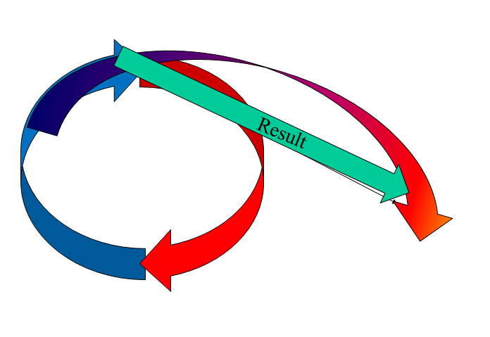I have suggested aggressive control inputs to move the glider from the off centre turn to the new core. You could consider reducing the angle of bank to get to the core of the thermal, but look at the consequences of doing this.  
If we roll out slowly, reduce our angle of bank and wait till we feel the peak of the vertical acceleration we will no longer start our new turn in the core of the thermal but rather some degrees off centre. We will then have to start re-centring again.  
However as you get more experienced, you can pre-empt the correction and start opening out the turn earlier. You will then have re-centred with less aggressive control inputs.

**To Nibble or Not to Nibble.**

I have suggested with regard to re-centring to feed in aggressive inputs and in effect try to move your thermal to the core in one move. It may be wise to make a number of small corrections rather than one big one with the risk of losing the core completely. In effect Nibble towards the core. That’s what Ingo told me anyway.

**Flying with other gliders.**

Please be highly aware that flying with other gliders requires safety to be paramount at all times. I am not going to go into these details in this article, other than to say.  
Fly Predictably.  
Fly Considerately  
Fly so that you can see the other gliders and they can see you. I.e. on the opposite side of the turn.  
Fly a similar circle as the other gliders. If you can’t fly 45° at about 10kts above stall speed, and they are, then keep out their way.

When we are flying there are three things that will give us the rate of climb of the thermal we are in.  
The Vario. This shows us History.  
Our body’s inner ear. This shows us what is happening now.  
Other Gliders and Eagles. They tell us what is going to happen, the future.

So to fly in a thermal with another competent pilot who is flying in a thermal on the opposite side of the turn. If you see them rising relative to you, you know that in the next 90° you will start rising at a better rate. 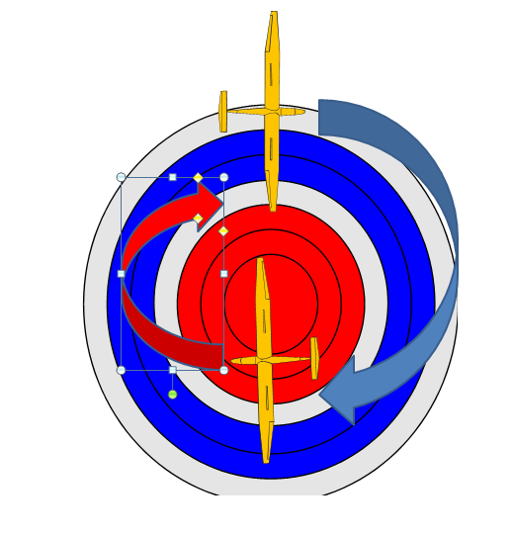You need to move towards their position.  
Equally if they start sinking relative to you, you know in 90° you will start sinking and you need do your best not to fly into that sinking air.  
So in the case of the diagram the glider at the top of the page is in sinking air, and the one at the bottom is in rising air.   
The glider in sink will open out their turn to extend **beyond** the rising glider  
The glider in rising air will tighten their turn to prevent them entering the sinking air. Once each of the gliders has made their correction move they will go back into the standard thermal of 45° bank and about 10kts above stall speed.

Hopefully by now you will notice that I never refer to the vario. The vario tells us History, our bum tells us what is happening now. A vario tells us our rate of climb, it is not a tool for centring.

**Streets.**

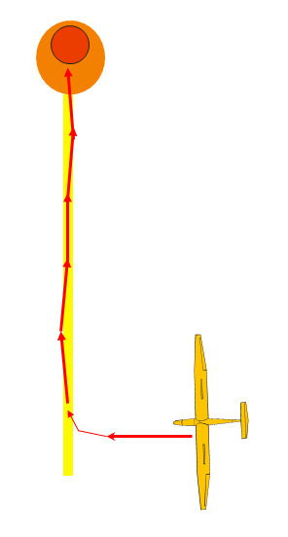One final matter in the entry of thermals. When there is much of a wind blowing streets form. Without going into detail of the structure of streets.(I have an article in my web page mentioned at the end of the article that gives far more details.) In principle the thermal will have a core with a tail like a comet or key hole, going down wind. This tail I estimate to be about 30m across. So the technique is that, on a windy day, when you find lift   
Turn directly into wind.   
Follow the street by carefully feeling the lift under either wing, moving may be 10° towards the lifting wing.  
You will notice that although the lift may be constant it tends to be a little turbulent.  
If there is a good core the air will become smoother and the lift stronger.  
It is only then that you turn in the thermal.

How many times at the end of the day have you heard some people saying that the day was rubbish, “I kept falling out the side of the I shaped thermals.”  
The more experienced pilots were saying it was a good day.  
It was streeting.

For future reference this article is on my web page.

[www.jamescooper.com.au](http://www.jamescooper.com.au)

Go to Gliding then Articles

Thermal Centring.

In addition I have used all of the article from a Power Point presentation that I have been using for many years. Again this is on my web page under Power Points

James Cooper

james@jamescoope.com.au